IP Address

Now that we covered GCP networks at a high level, let's go deeper by exploring IP addresses.

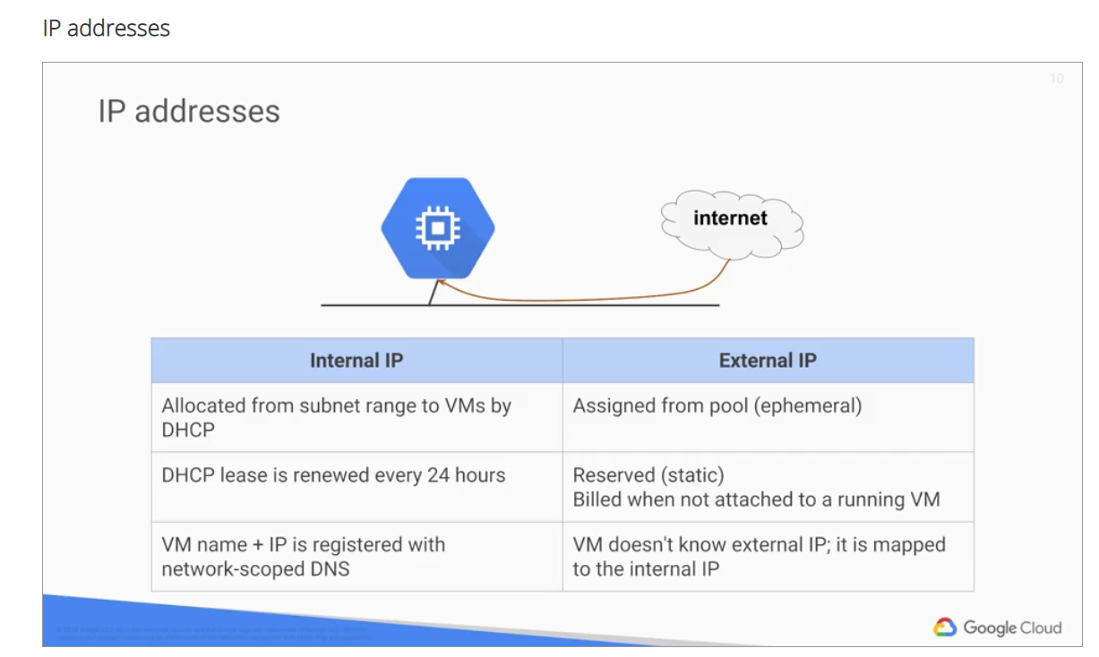

In GCP, each virtual machine can get two IP addresses assigned.

* Internal IP: One of them is an internal IP address, which is going to be assigned via DHCP internally. Every VM that starts up and any service that depends on virtual machines gets an internal IP address. Example of such services are Google App Engine and Kubernetes Engine which are explored in other courses. When you create VMs in GCP, their symbolic name is registered with an internal DNS service that translates the name to the internal IP address. DNS is scoped to the network, so it can translate web URLs and VM names of hosts in the same network, but it can't translate hostnames from VMs in a different network.
* External IP address: which is optional. In essence, you can assign an external IP address if your device or machine is externally facing. That IP address can either be assigned from a pool, making it ephemeral, or it can be assigned a reserved external IP address, making it static. Keep in mind that you're billed for reserving external IP addresses even when they're not attached to a running VM. Regardless of whether you use an ephemeral or static IP address, **the external address is unknown to the OS of the VM**. **The external IP address is mapped to the VM's internal address transparently by VPC**.

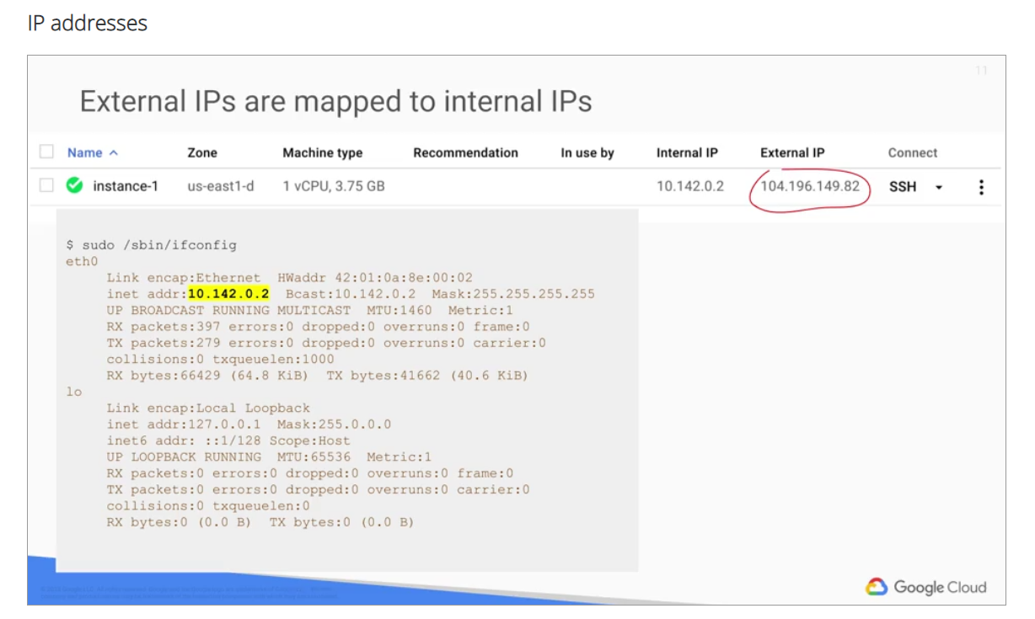 I'm illustrating this here by running IF config within a VM in GCP which only returns the internal IP address.

DNS resolution for both internal and external addresses:

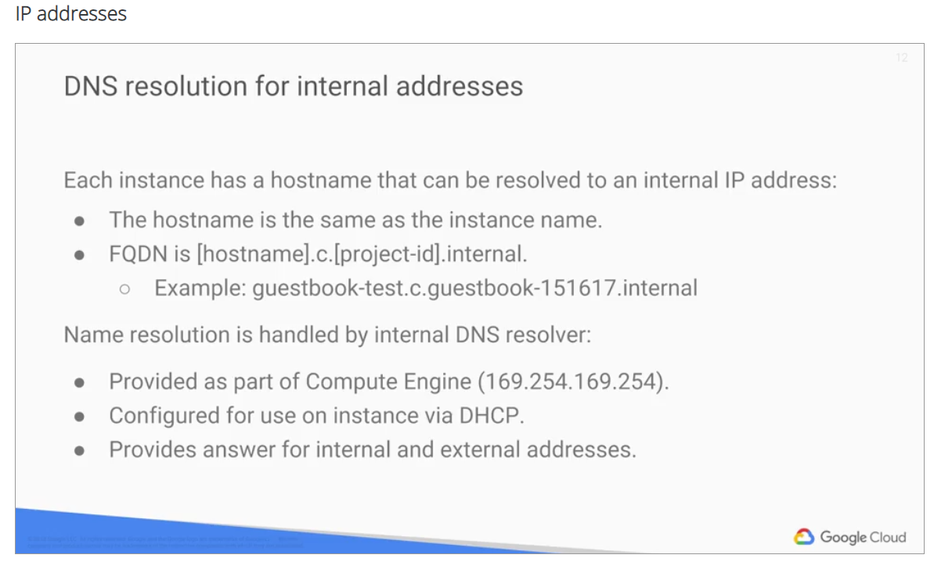

Let's start with internal addresses. Each instance has a hostname that can be resolved to an internal IP address. This hostname is the same as the instance name. There are also internal fully qualified domain name{s}, or FQDN for an instance that uses the format hostname.c.project-id.internal as shown on the slide. If you delete and recreate an instance, the internal IP address can change. This change can disrupt connections from other Google Compute Engine resources, which must obtain the new IP address before they can connect again. However, the DNS name always points to a specific instance no matter what the internal IP address is. Each instance has a metadata server that also acts as a DNS Resolver for that instance. The metadata server handles all DNS queries for local network resources and routes all other queries to Google's public DNS servers for public name resolution.

I previously mentioned that an instance is not aware of any external IP address assigned to it. Instead, the **network stores a look-up table** that matches the external IP address with the internal IP address of the relevant instance.

## External addresses:

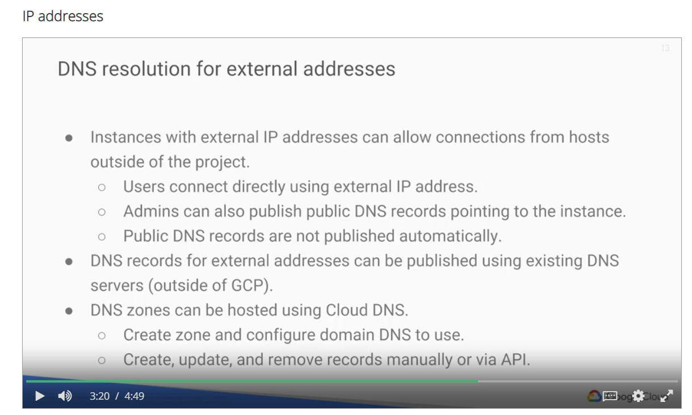

Instances with external IP addresses can allow connections from hosts outside of the project.

* Users can do so directly using the external IP address.
* Public DNS records pointing to instances are not published automatically.
* Admins can publish these using existing DNS servers. Domain names can be hosted on GCP using **Google Cloud DNS**. This is a managed service that is definitely worth considering, if you don't want to create your own BIND server and another VM.

## Alias IP ranges

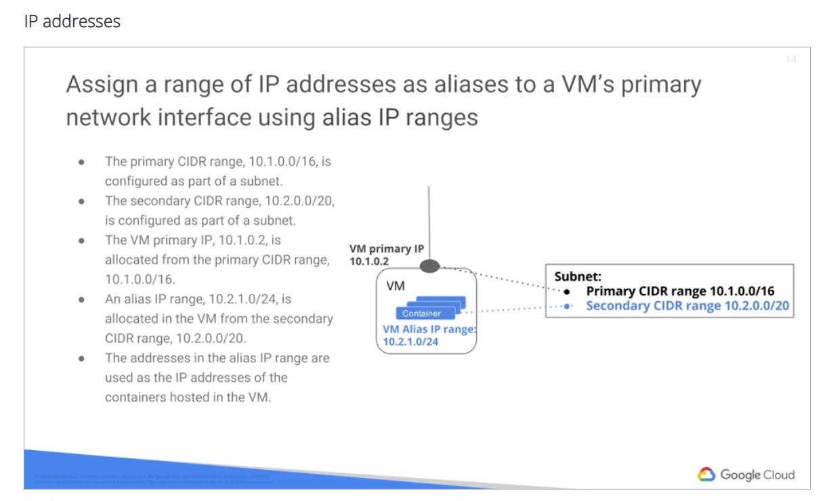

Another networking feature of GCP is **alias IP ranges**. Alias IP ranges lets you assign a range of internal IP addresses as aliases to a virtual machine's primary network interface. This is useful if you have multiple services running on a VM and you want to assign each service a different IP address. In essence, you can configure multiple IP addresses representing containers or applications hosted on a VM without having to define a separate network interface. You just draw out the alias IP range from the local subnets primary or secondary CIDR ranges. This diagram provides a basic illustration of primary and secondary CIDR ranges and VM alias IP ranges. Configuring alias IP ranges describes commands for setting up a subnet with secondary ranges and for assigning alias IP addresses to VMs.